

Hungarian University of Agriculture and Life Sciences
Doctoral School of Economic and Regional Sciences

SYRIAN REFUGEE CRISIS IN TURKEY AND ASPECT OF THE LABOR MARKET

The Thesis of The Ph.D. Dissertation

by
Neslihan Gökce UYGUR

Gödöllő, Hungary
2024

Hungarian University of Agriculture and Life Sciences

Name of Doctoral School: Doctoral School of Economic and Regional Sciences

Discipline: Management and Business Administration Sciences

Head of Doctoral School: Prof. Dr. Zoltán Bujdosó

Supervisor: Dr. habil. Ildikó Rudnák Ph.D.
Associate professor
Institute of Agricultural and Food Economics
Department of Agricultural Management and Leadership Science

……………………………………… …………………………………
Approval of Head of Doctoral School Approval of Supervisor(s)

CONTENTS

1. BACKGROUND OF THE WORK AND ITS AIMS 4
1.1 Background of the work 4
1.2. Objectives to Achieve 6
1.3. Research Questions 6
1.4. The Importance of The Topic 7
2. MATERIALS AND METHODS 8
2.1. Research model 8
2.2 Hypotheses of Research 9
2.3 Methodology: Interview and Survey 10
2.4 Data Collection 12
3. RESULTS AND DISCUSSION 13
3.1 Results 13
3.2 Discussion 20
4. CONCLUSION AND RECOMMENDATIONS 24
4.1 Conclusion 24
4.2 Limitations 26
4.3 Recommendations 26
5. NEW SCIENTIFIC RESULTS 29
6. REFERENCES 30
7. THE PUBLICATIONS OF THE AUTHOR IN THE RESEARCH FIELD 32

BACKGROUND OF THE WORK AND ITS AIMS

1.1 Background of the work
People migrate to survive in better living conditions sometimes voluntarily and sometimes by force due to war, exile, and disaster.
As the Syria crisis enters its twelfth year, the humanitarian situation is more difficult than ever. An estimated 15.3 million people need humanitarian assistance and more than half of the population remains displaced from their homes - including 5.3 million refugees living in neighboring countries and more than 6.8 million internally displaced inside Syria. Women and children comprise more than two-thirds of those displaced. Over the years, Syrians have shown remarkable resilience, but as the war continues, hope is fading fast. Over 90 percent of Syrians live under the poverty line, and it's estimated that 12 million people are food insecure and 2.5 million are severely food insecure as of Jan 2023 (UNHCR, 2023).
None of the Syrian citizens were turned back at the border for any reason, they were granted "temporary protection status" (Ozdemir, 2017; Kagnici, 2017). Turkey has come under a heavy economic burden by helping Syrian asylum seekers who have come to its country in an instant in every sense. However, none of Syria's citizens have been left to their fate (Ciftci, 2018). Economic, cultural, and psychological education support has been provided to refugee asylum seekers in camps. At the same time, the state of the Republic of Turkey has provided support for Syrian asylum seekers who want to live outside the camp to adapt to Turkish society by helping them with economic, cultural, educational, social, and psychological issues (Apak, 2015).
After the civil war in Syria, Turkey is one of the countries hosting the largest number of Syrian asylum seekers (Demirci and Kırdar, 2023). Since the first day of the crisis, Turkey has been carrying out its responsibility for Syrian refugees by using all its existing facilities (A World at School, 2015). It can be said that the process experienced by immigrants who are forced to leave their countries and flock to other countries results from new conditions, interventions, and 'domestic' policies in their countries (Erbaş, 2019). With the increase in immigrants in 2015, European countries implemented policies based on security concerns. It can be said that these countries are trying to minimize the number of immigrants heading towards them rather than the safety of immigrants' property and lives. Turkey is one of the countries most exposed to the influx of immigrants originating from Syria and still hosts the highest number of Syrian immigrants in the world, with 3,3 million (Directorate General of Migration Management (DGMM), 2023). Oxford University Centre for Migration, Politics and Society (COMPAS) researcher Duvell (2013) wrote about Turkey in his article ‘However, what is truly surprising is the social and political silence shown in the face of this refugee influx: Such a development, which would normally cause a moral panic in many other European countries, has not created such a situation in Turkey’ (Salli, 2022). Because Turkey has implemented an 'open door' policy since the first days of migration and has demonstrated an attitude within the framework of human rights and freedoms. By open-door policy, Turkey accepted Syrians into the country, directed them to accommodation centers from the first arrivals, and allowed them to settle wherever they wanted when it became a mass migration (Tunca and Karadag, 2018). This situation has brought about important discussions both inside and outside the country.
The addition of millions of Syrian refugees, in addition to the problems that Turkey is experiencing in the economic, political, and social fields, has caused the refugee problem to always be current in the country's politics. Before the elections held in May 2023, the refugee issue was on the agenda of both the government and opposition parties. The opposition treats the refugee issue as a survival issue, brings to the fore concerns that it will harm Turkey's demographic structure and that economic and social turmoil will occur, criticizes Turkey's immigration policy, and uses asylum seekers as an election promise.
The promise of repatriation has been the most talked about topic lately. In the face of this attitude of the opposition, the Government announced that it planned to send one million Syrian refugees voluntarily by building briquette houses in Syria within a year. While all these developments are taking place, refugees seem to be the most talked about issue in the next election due to reasons such as the fact that a decision regarding all Syrian refugees has not yet been made, Turkish society has started to experience more economic problems, inflation, and housing shortage.
The migration of Syrian refugees also poses several problems. These problems have economic, social, political, and social implications. Differences in language, culture, and lifestyle make social harmony difficult, and distorted structures increase. Also in economic terms, for example, there have been significant increases in health spending. There are also difficulties in terms of employment. Accordingly, it is assumed that many Syrians will remain in Turkey after the war's end (Aksoy and Ivrendi, 2023).

Objectives to Achieve
The three main objectives have been taken into consideration in this study.
(1) To measure the impact of Syrian refugees living under temporary protection in Turkey on the Turkish labor market.
(2) To examine the background and present, culture shock and physical and psychological symptoms, intergenerational differences, crisis (political, epidemic, economic, etc.), assimilation - integration - segregation and social integration process among Syrian refugees in Turkey, and to what extent the direct and indirect challenges have played a role in the process of their social and cultural integration.
(3) When the literature is examined, it is seen that there are not enough effective studies. The topic of Syrian refugees is a very young field, so future studies should examine how these experiences change at different stages of their lives over the long term. The Turkish economy, individuals, stakeholders, society, and new researchers are expected to benefit from this study.

Research Questions
This section proposes four main questions to articulate and interpret the study objectives. Addressing these questions will provide a clear and comprehensive analysis of the research. Answers to the following questions were sought in the study.
Q1: What are the reasons why refugees leave Syria and prefer to live in Turkey?
Q2: What problems do refugees face while joining Turkish society?
Q3: What are the problems of refugees who join the labour market in Turkey?

The Importance of The Topic
The aim is to analyze the experiences of asylum seekers coming to Turkey from their countries of origin in terms of labor markets and forced migration and to analyze the problems they encounter in the Turkish labor market in depth.
The impact of Syrian refugees on the Turkish labor market is also an issue that needs to be researched. In addition, the problems that asylum seekers face in their working lives stand out as another issue worth investigating. Because the refugees, who are at the forefront of the crisis, are the disadvantaged group who feel the direct effects of the crisis in the most relentless way. Besides the fact that asylum seekers are among the disadvantaged groups as immigrants; the possibility of being in this group as disabled, elderly, women, and children causes their labor to become more open to exploitation. Therefore, by focusing on Syrians in working life, this study becomes more inclusive in terms of forced migration literature. In addition, to refugees; the study thoroughly examines the experiences and problems of migration processes and work dynamics and is expected to be an important alternative resource for readers and researchers who want to examine this issue. For this reason, in this study, it is important to reveal the problems encountered in the labor market in Turkey in terms of asylum seekers.

MATERIALS AND METHODS

2.1. Research model
Figure 11 shows the refugee integration model. At the top of the model, characteristics of refugees, host-related factors, and policy framework are listed. The lower part shows integration, examining the refugees themselves and their impact on the host country. In reality, of course, the different dimensions of integration also influence each other. Two general types of institutions determine integration. The first concerns of host societies, such as Economic Impact, Employment, Cultural change, social cohesion, Strain on resources and public services, Attitudes towards refugees, Security, and Law. The second type is refugee groups Legal Rights, Adaptation, Language, Cultural, Social integration, Economic aspects, Attitudes towards refugees, Satisfaction.
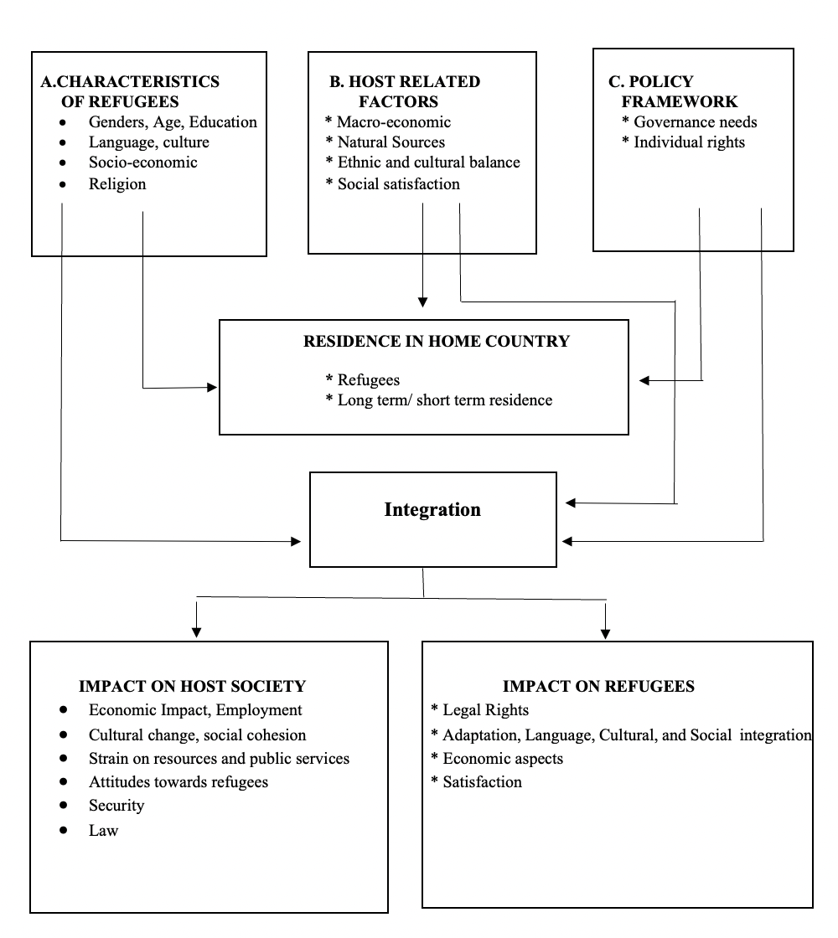
Figure 1. Research Model of Refugee Integration
Source: Author’s elaboration

2.2 Hypotheses of Research
Hypotheses whose accuracy will be controlled in the context of the variables in question within the scope of the research have been determined as given below:
H1: There is a significant difference between participants of different genders in their views on the Syrian refugee crisis in Turkey and its impact on the labor market.
The reason for choosing this hypothesis is that in Middle Eastern cultures, men are typically the breadwinners, and protectors of the family, and dominate the political, social, and economic spheres. Women, on the other hand, undertook child care at home.
H2: There is a significant difference between participants in different age groups in their views on the Syrian refugee crisis in Turkey and its impact on the labor market.
The reason for choosing this hypothesis is that The young age held by most Syrian refugees directly affects the age-group balance between Turkish natives and refugees themselves. the short-term consequences, a relatively large number of young Syrians are expected to crowd labor markets in regions with a heavy representation of refugees.
H3: There is a significant difference between participants with different levels of education in their views on the Syrian refugee crisis in Turkey and its impact on the labor market.
The reason for choosing this hypothesis is that an influx of low-skilled refugees can significantly impact different levels of education among local populations and adolescent refugees due to reduced opportunities and returns at the lower end of the labor market.
H4: There is a significant difference between participants with different working hours in their views on the Syrian refugee crisis in Turkey and its impact on the labor market.
The reason for choosing this hypothesis is that working conditions, low wages, longer working hours than Turkish workers, and working without social security payments have been the main problems in the workplace.
H5: There is a significant difference between participants with different total service times in their views on the Syrian refugee crisis in Turkey and its impact on the labor market.
The reason for choosing this hypothesis is that the first five years of working life are among the most important. This is when knowledge, skills, and competencies for better future opportunities are acquired. Different total service times matter in this concept.

2.3 Methodology: Interview and Survey
The research universe consists of all Syrian refugees living in Turkey and businesses where Syrian refugees work. In this context, the scope of the research and to constitute the sample of the study in Turkey, 10 Syrian refugees were interviewed for the application of the refugee interview form which is the “Syrian refugee crisis in Turkey and its effects on the Labour Market.”
For the application of the business interview form, 10 Syrian business employees and managers were interviewed. The study, by Cakir and Iscan (2019), used a field survey and interview form titled “The Effect of Asylum Seekers and Refugees in Turkey in the Turkish Labor Market: a Field Study,” developed by the researcher based on “Turkey in the Syrian Refugee Crisis and the Labor Market Effects of Business Interview Form.” This form includes five questions prepared to determine the social and economic problems of Syrian refugees living in Turkey and their impact on the labor market, and it is included in Annex 2.

- 10 Syrian refugees were interviewed for the application of refugee interview form which is the “Syrian refugee crisis in Turkey and its effects on the Labour Market”
In the study, by Iscan and Cakir (2019) “The effect in Turkish Labor Market of Asylum Seekers and Refugees in Turkey: A Field Study” used in the study, titled “The Effect of Asylum Seekers And Refugees in Turkey in the TurkishLabor Mmarket: a Field Survey and Interview Form” developed by the researcher based on “Turkey in the Syrian Refugee Crisis and the labor market effects of Refugee interview form” was used.
- 10 Syrian business employees and managers for the application refugee interview form which is the “Syrian refugee crisis in Turkey and its effects on the Labour Market Business”
The study, by Cakir and Iscan (2019) “The effect in the Turkish Labor Market of Asylum Seekers and Refugees in Turkey: A Field Study” used in the study, titled “The Effect of Asylum Seekers and Refugees in Turkey in the Turkish Labor Market: a Field Survey and Interview Form” developed by the researcher based on “Turkey in the Syrian refugee crisis and the labor market effects of Business interview form” was used.
In-depth interviews and participant observation techniques were applied to determine the situation regarding Syrian refugees. Semi-structured and Open-ended questions were prepared for the participants in advance, but new questions were asked to the participants according to the course of the conversation. The original content of the data obtained was adhered to and analyses were made by quoting what was said. Snowball or chain sampling technique was used to ensure that the research results were more realistic. Interviews lasted approximately half an hour. In addition, some of the interviews were conducted in Turkish and some in Arabic with the help of a translator.
In the research, the” descriptive method was used within the framework of the screening model, and the survey technique was applied as a data collection technique to make quantitative determinations about the “Syrian refugee crisis in Turkey and its effects on the labor market". Quantitative research can be expressed as a type of research that allows it to be presented in a measurable, numerically evaluated, and observable way by the objectification of facts and events. In this context, quantitative research methods that enable objective measurements and numerical data to be obtained through observation, experiment, and test offer the opportunity to obtain objective results (Balci, 2018).
The “screening model” applied within the scope of quantitative research is widely used in the social sciences and allows work in large groups. The screening model is expressed within the scope of research that does not have the researcher's manipulation of the independent variable and aims to describe a situation that exists in past periods or already in its current form (Büyüköztürk, 2014).
Quantitative research methods offer researchers several advantages in that they allow generalizable results to be produced, the degree of accuracy of theories to be determined, and the study of indexed relationships to a particular structure. However, the difficulties in determining the sample and collecting enough data, as well as the fact that the measurement tool can reflect biases, can also be expressed within the scope of the limitations of quantitative research methods. In the same way, the fact that quantitative research methods do not offer the opportunity to examine data other than the model is evaluated among their limitations (Balci, 2018).
” Descriptive method " can be expressed as a method that allows one to investigate and determine the current situation for a particular topic. "Survey technique", on the other hand, is defined as a data collection technique that allows systematic data acquisition by questions posed to participants in the universe or sample, depending on hypotheses established on a particular topic (Büyüköztürk et al., 2011).
- 391 business employees and managers answered the application of the” Syrian refugee crisis in Turkey and its effects on the labor market survey form". In addition to demographic information, a 5-point Likert-type scale was applied.
In the study, Cakir and Iscan (2019) “By The Effect in The Turkish Labor Market of Asylum Seekers and Refugees in Turkey: A Field Study titled” Study “is used in the effect of asylum seekers and refugees in Turkey in the Turkish labor market: a field survey questionnaire form” developed by the researcher based on “Turkey in the Syrian refugee crisis and the effects of the labor market survey form” is used. “Syrian refugee crisis in Turkey and its effects on the labor market survey form”; includes 10 questions prepared to determine the social and economic problems of Syrian refugees living in Turkey and their impact on the labor market.

2.4 Data Collection
In the research, a mixed research pattern was used, in which quantitative and qualitative research methods were used together. Syrian refugees living in Turkey and Turkish workers and managers constitute the research sample.
The research was carried out between 2020 and 2022 in various cities within the borders of Turkey, such as Istanbul, Ankara, and Adana. To investigate the research questions, as part of obtaining data from participants in the study, the demographic information form and the perspective scale for Syrian refugees were applied within the framework of the quantitative stage, while the semi-structured interview form was used in the qualitative stage.
In the quantitative phase of the study, 391 people were reached, while the qualitative study was conducted with 20 people.
Quantitative data SPSS (Statistical Package for the Social Sciences) 25 package program was used. The data analysis investigated what the interviews indicated about their processes of social and cultural integration in Turkey’s society as refugees.

3. RESULTS AND DISCUSSION

3.1 Results
H1: There is a significant difference between participants of different genders in their views on the Syrian refugee crisis in Turkey and its impact on the labor market.
A The average attitude scale score revealed statistically significant variations based on the gender of the employees when the findings were analyzed. This analysis contradicted our null hypothesis, finding statistically significant variations in the average attitude scale score based on the gender of the employees (t (387) = -6.93 p<.001). This finding indicates that sentiments about Syrians are more favorable among female employees (M=1.42, SD=0.33).
H2: There is a significant difference between participants in different age groups in their views on the Syrian refugee crisis in Turkey and its impact on the labor market.
A To find out if there was a significant difference between the age group of the employees and their attitude Scale scores on the impact of Syrian refugees on the labor market, a one-way variance analysis (ANOVA) was performed on the sample group of employees.
B The test result showed that there was a significant difference in the groups' arithmetic means (F (3,385) = 14,451; p<.001), rejecting our null hypothesis. Following this outcome, complementary post-doc studies were performed to identify the reasons for the variations.
C The attitude of employees aged 20-29 (m=1.46, SD=0.43) and over 50 (m=1.67, SD=0.44) toward Syria was less (negative) than that of other groups, based on the results of the Tukey test that was performed for this aim.
H3: There is a significant difference between participants with different levels of education in their views on the Syrian refugee crisis in Turkey and its impact on the labor market.
A Based on the outcomes of the assessment carried out for this objective, there are notable differences between every group. The Tukey test, designed specifically for this purpose, shows that employees with a negative attitude toward Syria have less than other groups of employees (m=1.40, SD= 0.32). Additionally, employees in this group have lower levels of elementary/primary education (m=1.81, SD= 0.52) and higher education (M=1.72, SD= 0.64) than other employees in the group.
H4: There is a significant difference between participants with different working hours in their views on the Syrian refugee crisis in Turkey and its impact on the labor market.
A The test result showed a significant difference in the groups' arithmetic means (F (2, 386) =12.946; p<.001), leading to the rejection of our null hypothesis.
B Following this outcome, complementary post-doc studies were performed to identify the reasons for the variations.
C The Tukey test conducted for this aim revealed that employees in the business who have been there for six to ten years (M=1.93, SD=0.74) had a higher positive view toward Syria than other groups of employees.
H5: There is a significant difference between participants with different total service times in their views on the Syrian refugee crisis in Turkey and its impact on the labor market.
A The test result showed a significant difference (F (2, 386) =24.57; p<.001) in the arithmetic mean of the groups, rejecting our null hypothesis. Following this outcome, complementary post-doc studies were performed to identify the reasons for the variations.
B Based on the outcomes of the Tukey test used for this purpose, there is a substantial difference between each group.
C People who have worked for 1 to 5 years (m = 1.45, SD = 0.42) are more likely to be negative about the effect of Syrian refugees on the labor market than people who have worked for 6 to 10 years (m = 1.96, SD = 0.68).
The prominent answers in the research are shown in Figure 2.
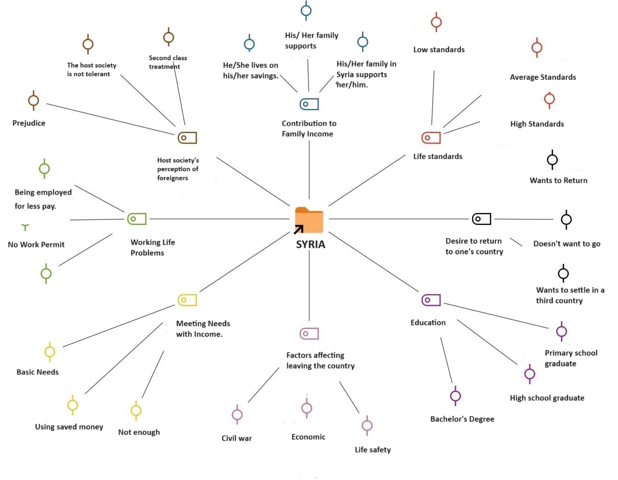
Figure 2. Participants’ Responses
Source: Author’s construction

When asked to compare the living standards in their countries with the living standards in Turkey;
Syrian refugees stated that the living standards in their country are worse than in Turkey, especially in economic terms. However, they stated that they lived in much worse standards due to reasons such as civil war, restriction of freedoms and state oppression. Some answers received from the participants are as follows:
“I was doing business in Syria, my living standards were much better, I am having financial difficulties here. Our financial situation in my country was very good.”
''I did not have any financial difficulties in my country, but I am having a hard time making ends meet here. "Finding a job was the most challenging issue for me."
When asked if their income levels meet their needs;
When the income levels of Iranian Refugees in Turkey and their ability to meet their needs are examined, they generally stated that their income in Turkey is not sufficient to meet their needs and that they have difficulty, but those who have savings can live more prosperously.
"I only earn enough money to meet our basic needs. I cannot fulfill my children's wishes."
''The salary I normally receive from my workplace is not enough to meet my needs. "My financial situation was good in Syria, I had savings, and I use that here too."
When the information about their professions in their countries and the sectors they work in Turkey is compared; When their professions in their country are compared with the sectors they work in Turkey, they stated that they work in more qualified jobs in their country, but since they cannot find a full match for their profession in Turkey, they work in jobs that they find close to their profession.
"I am a university graduate, but since my diploma is not valid," "I was a police officer when I was in Syria, but we cannot do the same job here. I can't do the same job here. I cannot work as a police officer without obtaining Turkish citizenship. Currently, I work in a plastic injection factory to continue my life and that of my family. I work as a worker.”
When we look at the findings regarding the extent to which it contributes to family income;
As a result of the interviews, it is understood that the majority of them left the country and came to Turkey with their families.
"I came here alone because I left Syria in a hurry. Then my family, namely my wife, daughter, and mother, came. I'm trying to make a living for them. At the same time, we still have an active shop in Syria. My uncle and my father founded it jointly. My uncle sends us money every month."
"I directly provide for the household. My wife also does irregular chores such as cleaning, cooking, etc. My oldest son is doing an internship at a vocational high school. "He has a salary paid by the state."
A) Information about the socio-demographic characteristics of individuals is given in Table 2, 90% of the participants were male, 10% were female, 60 % of the age were between 20-29 years, 50% were university graduates, and 90% were working in enterprise 1-5 years. 80 % of the participants' total service years were 11-15 years.
Table 2 Demographic Information on Refugees
Features | N=10 | %
Gender
- Men | 9 | 90
- Women | 1 | 10
Age
- 20-29 | 6 | 60
- 30-39 | 3 | 30
- 40-49 | 1 | 10
Education Status
- Secondary/High School | 3 | 30
- Bachelor’s degree | 5 | 50
- Master's degree/PhD | 2 | 20
Working Years In The Enterprise
- 1-5 years | 9 | 90
- 6-10 years | 1 | 10
Total Service Years
- 11-15 years | 8 | 80
- 16-20 years | 2 | 20
Source: Author’s elaboration
It is seen in Figure 3 the regions where the participants interviewed within the scope of the research lived in Syria before coming to Turkey were regions located in Northern Syria, relatively close to the Turkish border. Accordingly, most of the participants come from Aleppo, Hama, and Deir ez-Zor.
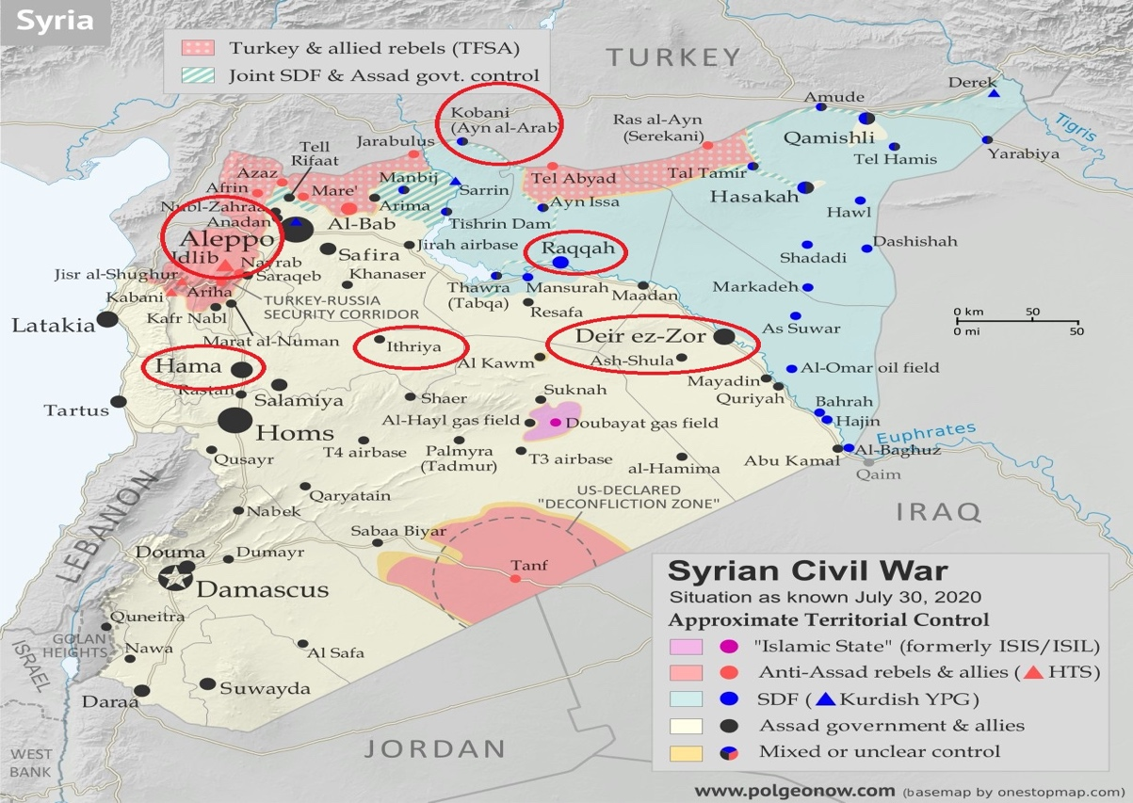
Figure 3. Distribution of Participants According to the Provinces They Came From Syria
Source: (Djukic, 2020)

B) Information about the socio-demographic characteristics of individuals is given in Table 3, 60% of the participants were male, 40% were female, 50 % of the age were between 30-39 years, 80% were university graduates, 50% were working in the enterprise 6-10 years and 70 % of the participants' total service years were 11-15 years.
Table 3. Demographic Information of Employees and Managers
Features | N | %
Gender
- Men | 6 | 60
- Women | 4 | 40
Age
- 20-29 | 4 | 40
- 30-39 | 5 | 50
- 40-49 | 1 | 10
Education Status
- Bachelor’s degree | 8 | 80
- Master's degree/PhD | 2 | 20
Working Years in the Enterprise
- 1-5 years | 4 | 40
- 6-10 years | 5 | 50
- 11-15 years | 1 | 10
Total Service Years
- 6-10 years | 1 | 10
- 11-15 years | 7 | 70
- 16-20 years | 2 | 20
Source: Author’s elaboration
C) The Syrian refugee crisis in Turkey and its effects on the labor market survey form was interviewed by 391 business employees and managers for its implementation. It was found that 60.4% of the participants were male and 39.6% were female in Table 4. When the distribution of these participants by age group was examined, 42.2% consisted of 20-29, 27.5% of 30-39, 15.9% of 40-49, and 14.4% of people aged 50 and over. A large proportion of participants ' educational status was found to be university graduates (57.1%). 66.8% of the participants were found to have between 1 and 5 years of work experience in the current institution. 43.7% of participants have a total work experience of 1-5, 37.5% have 11 years and over, and 18.8% have a total work experience of 6-10.
Table 4. Demographics of Participants of the Survey
Features | N=391 | %
Gender
- Men | 235 | 40
- Women | 154 | 60
Age
- 20-29 | 164 | 42,9
- 30-39 | 107 | 22,5
- 40-49 | 62 | 15,9
Education Status
- Primary School | 23 | 5,9
- Secondary/High School | 94 | 24,2
- Bachelor’s degree | 222 | 57,1
- Master's degree/PhD | 50 | 12,9
Working Years In The Enterprise
- 1-5 years | 260 | 66,8
- 6-10 years | 76 | 18,8
Total Service Years
- 1-5 years | 171 | 43,7
- 6-10 years | 74 | 18,8
- 11 years and over | 146 | 37,5
Source: Author’s elaboration
In this study, no limit was placed on the number of factors. However, dimensions whose eigenvalue (eigenvalue) is greater than 1 are considered the dimensions of the prepared scale.

3.2 Discussion
Before the factor analysis was carried out within the scope of the research, the Kaiser Meyer Olkin (KMO) and Bartlett Test were applied to determine whether the data set was suitable for factor analysis. The KMO value was obtained as 0.81, which shows that the data set is sufficient for factorial analysis. At the same time, the Bartlett Test result was determined as 2421.50 (p<.001), which shows that the relationship between the variables is statistically significant. The results of the factor analysis reveal that the factor structure of the scale is significant. The variance ratios obtained are compatible with the literature, showing that the scale has a strong factor structure. The factor loadings obtained for each item because of factor analysis help us understand the factors underlying the scale. For example, the high factor loading (0.932) obtained for the item "I think Syrian refugees have healthy working conditions in Turkey" shows that this statement has a strong relationship with the general factor of the scale.
Cronbach Alpha analysis results show that the internal consistency of the scale is high (0.92). This indicates that the scale measures reliably with the item set used and is suitable for obtaining consistent results. These findings show that the scale used is a reliable and valid tool and that inferences based on factor analysis results are based on a solid foundation.
Attitudes based on gender, analysis of attitudes based on gender shows that there are significant differences between male and female employees. It has been observed that the job satisfaction level of female employees is generally higher than that of men. This allows us to understand the effects of gender on experiences and attitudes in the business and make gender-based strategic improvements. Special strategies may be needed regarding female employees' leadership expectations, work-life balance assessments, and career goals.
Attitude differences according to age groups, analysis results reveal the existence of significant attitude differences between different age groups. Young employees' attitudes towards work were generally evaluated as more positive and innovative. This shows that the dynamism and openness to change that the young generation brings to the business world can be an advantage for organizations. Additionally, implementing strategies such as mentoring programs among older employees can encourage them to share their experiences and increase collaboration within the organization.
The complexity between education level and attitudes, complex relationship between education level and attitudes of business employees, requires a detailed analysis. While it is observed that individuals with higher education levels generally have a more positive attitude towards work, it should not be forgotten that this may also indicate inequalities within the organization. Equal opportunity strategies and training programs based on education level can play an important role in achieving this balance.
When the effect of working time in the company and the relationship between working time in the company and attitudes are examined, it is seen that long-term employees generally have a more positive attitude towards work. This may indicate that the corporate culture and the employee's integration with the organization are formed over time. However, orientation and integration programs may need to be reviewed to ensure that new employees adapt faster.
The role of total work experience and evolutionary attitudes. The relationship between total work experience and attitudes allows us to understand the evolution of the employee in business life. It has been found that individuals with more work experience generally have a more positive attitude towards their jobs. This may require organizations to focus on ongoing training and development programs to respond to the evolving needs of their workforce.

This research encountered certain limitations, which may impact the overall validity of the study and the interpretability of its results. Understanding these limitations is important to guide future researchers and expand knowledge in this field. One of the limitations of the study relates to the sample. The research is based on a specific sample and this sample may not fully represent the general population. This may limit the external generalization of the study. Future researchers may consider overcoming this limitation by using larger and more diverse sample groups.
Additionally, the cross-sectional design of this study has limitations. Based on data at a specific point in time, it can be difficult to establish causal relationships. Future researchers may strive to understand changes over time better using longitudinal designs or experimental approaches.
Considering the overall context of the research, another limitation of this study is that it focused on a specific geographic region or industry. Future researchers can increase the generalizability of the results by conducting similar studies in different geographic regions or industries.
As for recommendations for future researchers, they may be suggested to explore more specific topics based on the findings of this study. Additionally, repeating similar research in different contexts or trying different methodologies can enrich knowledge in this field.
Being aware of the limitations of this study provides opportunities for future researchers to overcome these limitations and may create new possibilities for expanding the knowledge base in this field.

4. CONCLUSION AND RECOMMENDATIONS

4.1 Conclusion
This research addresses an important problem that stands out with its contributions to knowledge production. Its overall aim is to develop a detailed understanding of the Syrian refugee crisis and its effects on the Turkish labor market and to fill knowledge gaps in this field.
In light of this purpose, the research addresses topics such as evaluating the Kaiser Meyer Olkin (KMO) and Bartlett Test results, the significance of the factor structure of the scale according to the factor analysis results, the factor loadings obtained for each item, and the interpretation of these loadings.
The importance of the research comes from enriching the literature in the field by producing in-depth information in line with its determined purpose. It is important that the findings fill the gaps in the literature, especially the analysis of attitudes according to demographic variables, and expand and strengthen the existing knowledge in this field.
In addition, within the scope of analyzing attitudes according to demographic variables, the research examines in depth the effects of factors such as gender, age, educational status, working time in the enterprise, and total work experience on attitude differences. This analysis makes a significant contribution to the field by understanding the effects of each demographic variable on attitude and comparing these effects with the existing literature.
The contributions of the research are evident not only in theoretical terms but also in practical applications. The findings may influence the management practice of businesses, the teaching strategies of educational institutions, or practices in other sectors.
In this context, the research provides valuable information for strategic planning based on demographic variables.
Participants cited terror and war as the reasons that drove people to emigrate the most. Although their view of Syrian migrants in general is negative, it has been determined that they are not very opposed to their arrival unless they break the order of the country. In short, it has been determined that local people are ambivalent about Syrian migrants, on the one hand, they think that they should be helped, and on the other hand, they have concerns.
Syrian refugees working in the business seem to be responding that they need more economic income, housing, and health care to care for themselves and their families and support their children to benefit from educational opportunities.
According to average data, the university education that Syrians receive and the work of Syrians in jobs appropriate to their specialty have a more positive attitude/perception; primary school - high school graduates have a more negative attitude/perception.
As a result, the overall importance of this research is the effort to contribute to the construction of a society based on knowledge production. Steps such as associating the findings with the literature, making comparisons with similar studies, and comparing the attitude scale with similar scales increase the methodological soundness and scientific contribution of the research.
Reminding the general purpose of the research emphasizes the importance of this study and explains the contributions of the obtained results to the field. Analyze whether the main hypotheses are accepted or not and determine the basic framework of the research. First, factor analysis results were examined.

4.2 Limitations
As every study or research is bound to have some limitations, this study also realized some limitations. For instance, the study sample which is Syrians might not be the best representative of the total population of the country under study as Turkey is a big country. So, future studies can be conducted by taking into consideration other parts of the country as well.
Due to a lack of resources and time, and restrictions faced by the researcher because of covid-19 pandemic, this study could not involve a comparative study between the countries.

4.3 Recommendations
When the general appearance of Syrian refugees in the Turkish labor market and the positive and negative changes they bring about in the labor market are evaluated, the following solution suggestions have been made. It is thought that the suggestions to be presented will contribute to eliminating the problems experienced by refugees and implementing practices to combat the negative perception towards refugees.
The recommendations are listed as follows:
- Education and awareness-raising activities should be carried out for local people and other immigrant groups to change the negative perspective towards refugees and to combat exclusion.
- By utilizing refugee labor according to the regional needs of the labor market, job opportunities can be created and necessary vocational training can be provided. Additionally, employers can be supported by identifying the problems faced by employers.
- Companies should be regularly informed by the professional chambers they are members of about the laws and procedures regarding the employment of Syrian employees.
- Chambers of industry and/or commerce and chambers of tradesmen, whose members include companies with Syrian capital, should establish a Syria Desk within their bodies to inform the relevant companies about the current legislation and changes in the legislation.
- Since identifying the problems experienced by refugees is important in determining the areas where solutions will be produced, comprehensive research should be conducted on what these problems are.
- Refugees should be ensured to benefit from language and educational opportunities. Employers should encourage the Syrians they employ to learn Turkish, and they should be encouraged to learn professional Turkish through in-house training.
- Housing conditions should be improved in response to the housing problem that refugees experience.
- They should be motivated to facilitate the process by involving their efforts in dealing with the problems that refugees face in terms of adaptation.
- After determining the problems that refugees experience in terms of adaptation, their participation in the workforce should be ensured through efforts to eliminate these problems.
- To make it easier for Syrians to find jobs that suit their qualifications and to increase their awareness of registered employment, they should be able to benefit from İŞKUR career counseling services more effectively and widely.
- Syrians should be given training on CV preparation and interview techniques.
- Awareness of gender equality should be increased to increase Syrian women's participation in the workforce.
- After approximately 12 years, it should be accepted that Syrians are no longer "temporary" or "guests" in Turkey, and policies regarding the adaptation process should be built on this premise. Turkey needs an immigration policy that addresses the immigration issue, which is a multi-layered issue, with a holistic approach.

5. NEW SCIENTIFIC RESULTS
- My research on the impact of the Syrian refugee crisis on the Turkish labor market has revealed several new insights (importance of urgent income, inadequate working conditions, substandard work) and longer-term demographic trends, social organization, and even economic development can therefore be considered as a gap-filling study.
2. Syrian refugees with degrees in their field of expertise have a faster and more positive integration process than those with lower qualifications. The challenges faced by Syrian refugees are complex, so interventions aimed at helping them overcome the challenges related to their status in the Turkish labor market need to be
3. This research indicates that education and awareness programs aimed at ending the exclusion of refugees in society are sorely needed.
4. The exodus of Syrian refugees has had a clear effect on the job market in Turkey: it also means more competition in labor markets and changes to some aspects of how the labor market works, at the same time to fill labor shortages in certain areas of work and to bring skills and experience to the new countries.
5. It plays a prominent role in the permanent resettlement and continued prosperity of refugees “The Syrian entrepreneurial talent” outstanding key skills, at the same time the cultural assimilation of Syrian refugees into Turkish culture is also essential.
6. Legal changes need to be made to meet the special circumstances of Syrian refugees including streamlining work permits, access to legal services, and the protection of refugee rights.

6. REFERENCES
- Aksoy, N., & Ivrendi, M. (2022). Testing The Validity of Wagner's Law and Keynes Hypothesis Before and After Syrian Refugee Migration: The Case of Turkey. Journal of Management and Economics Research, 196-213.
- Balcı, A. (2018). Research methods, techniques, and principles in Social Sciences. Pegem Publishing House.
- Buyukozturk, S. (2014). Experimental patterns: pre-test-final test, control group, pattern, and data analysis. Ankara: PegemA Publishing house.
- Buyukozturk, S., Kilic, E., Akgun, O. E., & Karadeniz, S. (2018). Scientific research methods. Pegem Akademi.
- Ciftci, H. (2018). An Analysis of the Empathic Behaviour and Attitudes of Turkish Citizens Towards Syrian Refugees and Their Perception of These Refugees. Journal of human and social sciences research, 7/3, 2232-2256.
- Directorate General of Migration Management (DGMM). (2023, October 15). Syrians Under Our Temporary Protection. https://www.goc.gov.tr/gecici-korumamiz-altindaki-suriyeliler adresinden alındı
- Directorate General of Migration Management. (2020, November 16). Temporary Protection. Ministry of Interior: https://www.goc.gov.tr/gecici-koruma5638 adresinden alındı
- Demirci, M., & Kırdar, M. G. (2023). The labor market integration of Syrian refugees in Turkey. World Development, Elsevier, Volume 162.
- Erbaş, H. (2019). The Concept of Migrant Crisis and What It Covers Up: Today's Immigration Situations, Contradictions and Problems. Migration and Immigrants from Departures to Escapes: Theory, Methods and Field Papers (Ankara: Phoenix Publishing House), 315.
- Erdogan, M. (2019). Syrian refugees in Turkey. Konrad Adenauer Stiftung, 2-25.
- Erdogan, M. (2020, March 9). Syrians in Turkey from Open Door Policy to Open Border Policy. https://www.uikpanorama.com/blog/2020/03/09/acik-kapi-politikasindan-acik-sinir-politikasina-turkiyedeki-suriyeliler-murat-erdogan/ adresinden alındı
- Erdogan, M. M. (2014). Syrians in Turkey: Social Acceptance and Compliance. Hacettepe University Center for Migration and Politics Studies-HUGO.
- Esen, A., & Duman, M. (2019). Syrians Under Temporary Protection in Turkey: Determinations and Recommendations. Istanbul: Aryan Basım Promotion and Printing House.
- Ekiz, D. (2003). Introduction to research methods and methods in education: qualitative, quantitative and critical theory methodologies. Anı Publications.
- Iscan, I. H., & Cakır, M. (2019). The impact of asylum seekers and refugees in Turkey on the Turkish labor market: a field study. Journal Of Social Policy Studies, 43, 177 – 236.
- Iscan, I. H., & Cakır, M. (2019). The Turkish Labor Market Impact of Refugees and Asylum Seekers in Turkey: a Fıeld Study. Journal Of Social Policy Studies, 177-236.
- Karasar, N. (2012). Scientific research method. Ankara: Nobel Publications.
- Ozbey, K. (2022). From Open Door Policy to Border Wall Project: Transformation of Turkey’s Border Policy. Uludağ University Faculty of Arts and Sciences Journal of Social Sciences / Volume: 23 Issue: 43, 709-741.
- Ozdemir, E. (2017). Effects of Syrian Refugees Crisis on Turkey. International Journal of Crisis and Political Research, 114-140.
- Salli, A. (2022). From “Crisis” to “Harmony”: Syrian Immigrants In Turkey And Religion In The Context Of Socio-Cultural Dimensions. Bingol university faculty of theology journal- Issue 19, 24-45.
- Tunca, O. H., & Karadag, A. (2018). Migration from Syria to Turkey: Threats and Opportunities, Military Academy Science Journal, Volume 28, Issue 2, 47-68.

7. THE PUBLICATIONS OF THE AUTHOR IN THE RESEARCH FIELD

- Uygur, G., Gunaltay, A. and Rudnak, I. (2023). Job satisfaction and organizational commitment in Syrian refugee textile enterprises: A case study from Turkey. Problems and Perspectives in Management, 21(4), 13-24. SCOPUS Q2, doi:10.21511/ppm.21(4).2023.02
- Shahbaz, A.S., Uygur, G. and Dunay, A. (2023). Sustainable project management for humanitarian disasters and refugee crisis management: Bibliometric analysis. Problems and Perspectives in Management, 21(3), 543-557. SCOPUS Q2, doi:10.21511/ppm.21(3).2023.43
- Uygur, G., Gunaltay, A. and Rudnak, I. (2021). Electronic Human Resources Management: A Research In Syrian Refugee Companies In Turkey. Zeszyty Naukowe Wyższej Szkoły Humanitas 22 : 1 pp. 9-22. , 14 p. (2021). Retrieved fromhttps://zeszytyhumanitas.pl/resources/html/article/details?id=215620
- Uygur, G. and Szigeti, Sz. (2021). Emberierőforrás-menedzsment (HRM) és a COVID–19 Törökországban In: Kőműves, Zsolt Sándor; Szabó, Katalin; Szabó-Szentgróti, Gábor; Poór, József (eds.) Koronavírus-válság kihívások és HR-válaszok – hazai és nemzetközi tapasztalatok 2020 Bp, Hungary : Wolters Kluwer Hungary Kft. (2021) 318 p. Paper: 21. fejezet. 4. ország esettanulmány Study(Chapter in Book)
- Uygur, G. (2020). Syrıan Refugee Entrepreneurs ın the Labour Market: the Case of Istanbul. Türkiye Sosyal Araştırmalar Dergisi , 24 (1) , 99-110 . Retrieved fromhttps://dergipark.org.tr/tr/pub/tsadergisi/issue/53617/684302
- Uygur, G. and Rudnak, I. (2020). The Place of Syrıan Refugee Women in the Labor Force and theır Experıences: The Case of Ankara. Idea Studıes Journal - International Journal of Disciplines Economics &amp; Administrative Sciences Studies 6: 23 pp.751-758, 8p. Retrieved from http://ideastudies.com/Makaleler/1582541230_8_6-23_324_Uygur_751-758.pdf
- Uygur, G. and Rudnak, I. (2020). Syrıan Refugee Management: The Role of Istanbul Metropolıtan Munıcıpalıty. Vadyba: Journal Of Management, 2(36) pp. 35-41. , 7 p. Retrieved from https://www.ltvk.lt/file/zurnalai/35_41.pdf
- Uygur, G. (2019). What are the characteristics of Syrian refugee entrepreneurs in Turkey? In Innovation Management, Entrepreneurship and Sustainability (IMES 2019) (pp. 979-991). Vysoká škola ekonomická v Praze. https://imes.vse.cz/wp-content/uploads/2019/07/Conference_Proceedings_IMES_2019.pdf
- Uygur, G. (2018). Influence of refugee’s status in small and medium enterprises in Turkey. Acta AVADA Nr.5.,2018, Vilnius. (pp. 29-35). Akademinė Vadybos ir Administravimo Asociacija. http://acta.avada.lt/acta-avada-numeriai/2018-nr-5

